Undergraduate Concentrators’ Handbook Slavic Literatures and Cultures

2023-24

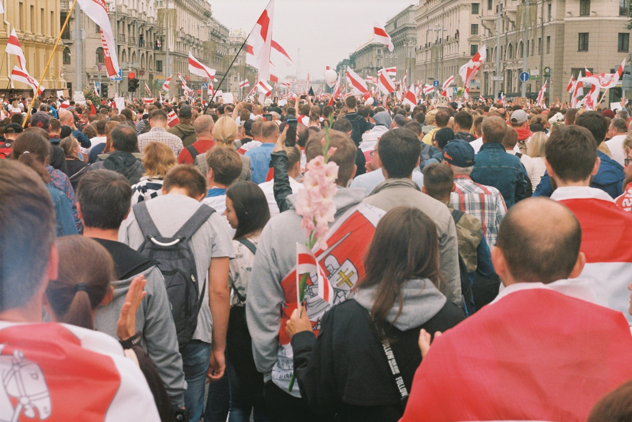

In 2020, after Belarusian president Alexander Lukashenko was reelected in what was widely regarded as a sham election, Belarus erupted in waves of protest. Draped in the red and white flag of the pre-Soviet Belarusian Democratic Republic, wide swathes of Belarusian society took to the streets demanding political freedom and social change. While the protests in Belarus were violently suppressed, they illustrated the region’s history of spirited debate and resistance to oppression, a thread running from Solidarity in Poland, to Charter 77 in the former Czechoslovakia, through to contemporary ‘railway partisans’ in Russia and Belarus.

The Department of Slavic Languages and Literatures Harvard University
Cambridge, Massachusetts

THE PURPOSE OF THIS HANDBOOK

This handbook is designed to give you all the information you need about the concentration in Slavic Literatures and Cultures and the many special offerings of the Slavic Department at Harvard. We recommend that you read the handbook in its entirety. We have made every attempt to provide the most up-to-date information on course offerings, requirements, off- campus study programs and university resources. Please do not hesitate to consult the Director of Undergraduate Studies (DUS), Professor Stephanie Sandler (ssandler@fas.harvard.edu) about any details regarding your program.

UNDERGRADUATE PROGRAM CONTACTS

Stephanie Sandler, Ernest E. Monrad Professor of Slavic Languages and Literatures and Director of Undergraduate Studies.
Barker #321, ssandler@fas.harvard.edu

Steven Clancy, Senior Lecturer and Director of the Language Program.
Barker #325, sclancy@fas.harvard.edu

Justin Weir, Curt Hugo Reisinger Professor of Slavic Languages and Literatures, Professor of Comparative Literatures, and Chair of the Slavic Department.
Barker #377, weir@fas.harvard.edu

Penelope Skalnik, Department Administrator.
Barker #374, pskalnik@fas.harvard.edu

Augustus Gilchrist, Department Coordinator.
Barker #380, augustus_gilchrist@fas.harvard.edu

TABLE OF CONTENTS

SLAVIC LITERATURES AND CULTURES

OVERVIEW: WHY CHOOSE SLAVIC STUDIES? 7-8
BASIC REQUIREMENTS/ JOINT REQUIREMENTS 9-11
REQUIREMENTS FOR HONORS 11-12
READING COURSES 12
CONCENTRATION CREDIT FOR OFF-CAMPUS STUDY 12
ADVISING 12-13
THE DEPARTMENT 13

CAPSTONE PROJECTS AND HONORS THESES
- SENIOR-YEAR CALENDARS 15-16
- MAKING THE DECISION 17
- CHOOSING A TOPIC AND ADVISOR 17-23
- GRANTS FOR THESIS RESEARCH 23
- MANAGING THE PROJECT 23-27
- GRADING 27-30
- PRIZES 30

HONORS
- HONORS REQUIREMENTS 30
- DETERMINATION OF HONORS 30

CAMPUS RESOURCES
- LIBRARY RESOURCES 31-32
- THE DAVIS CENTER FOR RUSSIAN AND EURASIAN STUDIES 32
- THE HARVARD UKRAINIAN RESEARCH INSTITUTE 32-33
- OTHER RESOURCES 33

OFF-CAMPUS STUDY
- STUDY ABROAD 34-38
- SUMMER STUDY IN THE U.S. 38-39
EXTRACURRICULAR OPPORTUNITIES 40
DEPARTMENT STAFF 41
DEPARTMENT FACULTY 41-43
TRANSLITERATION OF RUSSIAN 44-45
SECONDARY FIELDS 46-47

Slavic Languages and Literatures

WHY CHOOSE SLAVIC STUDIES?
The concentration in Slavic Literatures and Cultures offers you the opportunity to study the great works and cultural traditions, past and present, of Ukraine, Poland, Russia, Bosnia-Croatia-Serbia, and the Czech Republic. These countries share a rich cultural life as well as a turbulent and fascinating history. In the Slavic concentration, you will develop proficiency in a Slavic language such as Czech, Russian, Polish, Bosnian-Croatian-Serbian, or Ukrainian; you will learn to read literary works in the original language, gain valuable experience for working and traveling abroad, and come to understand these cultures and the important role they have played in the modern world. The concentration requirements are four semesters in a Slavic language (Russian, Ukrainian, Polish, Czech, or Bosnian-Croatian-Serbian), Introduction to Slavic Literature and Culture, a tutorial normally taken in either the sophomore or the junior year, two 100-level courses in Slavic literature and culture, and three additional electives from the Slavic Department or in related departments. Native speakers and students with advanced language preparation may substitute additional literature courses for a substantial part of the language requirement.
Introduction to Slavic Literature and Culture, the Slavic Department tutorial, will give you a rigorous introduction to contemporary methodologies of reading texts and studying foreign cultures. All tutorials in the Slavic department are taught by our full-time faculty. Introduction to Slavic Literature and Culture will introduce students to major issues in the field of Slavic studies, including critical theory, modes of interpreting literary texts as well as visual culture, and the forces structuring national and regional identities. Many of our concentrators combine a love of literature with a strong interest in other disciplines, and we highlight the interdisciplinary nature of Slavic studies by incorporating questions of history, politics, and visual culture in Introduction to Slavic Literature and Culture and other department courses.
Electives can be chosen from among Slavic Department courses, or can be taken in related Departments (History, Comparative Literature, Linguistics, etc). In the senior year, non- honors concentrators will design a fall-term capstone project in consultation with the Director of Undergraduate Studies (DUS), allowing them to study with a Slavic Department faculty member and write a 25–30-page senior project. Honors candidates will work with a faculty member for the entire senior year and write a thesis. The department awards prizes for superior honors theses.
In addition to the required survey course in Russian literature, students are encouraged to use their two elective courses to explore a broad variety of subjects. Our courses will let your read deeply in the works of Tolstoy, Dostoevsky, Shevchenko, Nabokov, Mickiewicz, Bulgakov, Kundera, and many others. You may study topics like the interwar avant-gardes in literature, art, and film; the cultures of great European cities, such as St. Petersburg, Kyiv, and Prague; twentieth-century Ukrainian literature and its political contexts; the culture of Medieval Rus’; Russian women readers and writers; the Russian theater and ballet; Russian and Central European film; Slavic science fiction; and the traditions of Slavic intellectual history from anarchism to Communism and political dissent. Many of our courses cover aspects of Slavic critical theory (formalism, structuralism, Bakhtin, cultural semiotics), as well as other contemporary theoretical approaches to literature.

The department welcomes all students with an interest in Slavic languages and cultures and is happy to accept late transfers so long as the applicants have already begun language study. To be sure, the undergraduate concentration will prepare you for graduate study in Slavic, comparative literature, history, and other advanced humanities degrees. But most of our students follow careers in other areas, including publishing, medicine, law, business, and government. They find that the experience of learning a language and getting to know a foreign culture greatly expands their opportunities for work and travel. Above all, the concentration seeks to provide intellectual stimulation along with linguistic and analytic skills that will serve all students well in their future careers.

Study abroad remains a popular option for many of our students, however study abroad in Russia and Ukraine is not possible under current conditions. Fortunately, many of the most reputable and longstanding study abroad programs for Russian and Ukrainian have resumed operations in countries such as Kazakhstan, Kyrgyzstan, Estonia, Moldova, and Georgia. In the past, the majority of our concentrators spent time abroad, typically during their junior year or in the summer after their sophomore or junior year. Usually, the Slavic Department offers a summer abroad program in Prague (for the study of Czech) and Tbilisi (for the study of Russian) each year through the Harvard Summer School. Many of our students have also studied in Russia or Central Europe with other programs such as Bard-Smolny Program (now Bard-American University of Central Asia, in Bishkek, Kyrgyzstan), the American Council of Teachers of Russian (ACTR), or the Council on International Educational Exchange (CIEE); entrance to these programs is competitive, but Harvard students have traditionally done well. Credit toward concentration requirements is granted to those who successfully complete such programs; in order to receive concentration credit for this or any other external study, the student must receive permission in advance from the Director of Undergraduate Studies. Slavic Department faculty and staff are constantly monitoring issues of safety for travel abroad and we will always revise our recommendations in accordance with current university and other federal guidelines.

BASIC REQUIREMENTS: 11 courses
- Required Courses:
  - Four semesters in a Slavic language (Russian, Ukrainian, Polish, Czech, or Bosnian-Croatian-Serbian); all four must be taken in the same language. Native speakers, or students with advanced language preparation, must take at least one language course in the department, and have the option of testing out of the other three courses, which they would take in literature instead.
  - Introduction to Slavic Literature and Culture (see item 2).
  - Two 100-level courses in Slavic literature or culture.
  - Three additional electives from the Slavic Department or in related Departments (relevant courses in Comparative Literature, Linguistics, History, Anthropology, etc).

- Tutorials:
  - Introduction to Slavic Literature and Culture, a tutorial normally taken in either the sophomore or the junior year.

- Capstone Project: The non-honors capstone project (Slavic 99a) will be a 25–30-page research paper or annotated translation, developed in consultation with the DUS and written under the guidance of a faculty advisor. Graded SAT/UNSAT

- Other information:
  - The three elective courses may include any Slavic Department literature or linguistics course at the 125 level or above; Slavic-related Gen Ed courses, a First-Year Seminar or relevant courses in the Departments of Comparative Literature, Linguistics, AFVS, Anthropology, History, Government, etc., if approved by the Director of Undergraduate Studies; or an Independent Study approved by the Director of Undergraduate Studies.
  - All courses for the concentration must be graded, except approved First-Year Seminars and Slavic 99a, which are graded SAT/UNSAT.

JOINT CONCENTRATION REQUIREMENTS.
SLAVIC AS PRIMARY FIELD: 9 courses.
- Required Courses:
  - Two semesters in a Slavic language (Russian, Ukrainian, Polish, Bosnian-Croatian-Serbian, or Czech); both semesters must be taken in the same language. Native speakers, or students with advanced language preparation, must take at least one language course in the department, and have the option of testing out of the other three courses, which they would take in literature instead.
  - Introduction to Slavic Literature and Culture. See item 2.
  - Two 100-level courses in Slavic literature or culture.

  - Two additional courses from the Slavic Department or in related areas.

- Tutorials:
  - Introduction to Slavic Literature and Culture, a tutorial normally taken in either the sophomore or the junior year.

- Thesis: Two terms (Slavic 99a and 99b) required. Graded SAT/UNS. (Progression to 99b will be contingent on satisfactory completion of 99a.)

SLAVIC AS ALLIED FIELD: 6 courses.
- Required Courses:

  - a. Two semesters in a Slavic language (Russian, Ukrainian, Polish, Bosnian-Croatian-Serbian, or Czech); both semesters must be taken in the same language.

Native speakers, or students with advanced language preparation, must take at least one language course in the department, and have the option of testing out of the other course, which they would take in literature instead.
b. Introduction to Slavic literature or culture, a tutorial to be taken in either the sophomore or the junior year.

  - Two 100-level courses in Slavic literature or culture,

  - One additional course in the Slavic Department or in related Departments.
- Thesis: 99A and 99B courses should be taken in your primary department. However, your thesis must engage substantially with sources in a Slavic language. In addition to evaluation of your thesis in your primary department, one reader from the Slavic Department will be assigned to evaluate and grade your thesis.

100-level Courses in Slavic literature/culture
In 2023-24 the following courses will count toward the two 100-level courses in Slavic literature or culture requirement: Slavic 133: Modernist Journeys (fall); Slavic 175: Between East and West: A Critical Mapping of Polish Culture (fall); Slavic 191: Silent Film (fall); Slavic 121: Ballet, Past and Present (spring); Slavic 147: Russian Fiction in the Soviet Era (spring); Slavic 171: The Holocaust in Polish Memory and Culture (spring).

REQUIREMENTS FOR HONORS ELIGIBILITY: 12 courses
Honors Requirements are identical to the Basic Requirements, with the exception of the Senior Thesis, a two-semester sequence culminating in a thesis of approximately 70 pages (see pages 11-21).

- Required Courses:
  - Same as Basic Requirements.
  - Same as Basic Requirements.
  - Same as Basic Requirements.
  - Same as Basic Requirements.

- Tutorial:
Introduction to Slavic Literature and Culture, a tutorial normally taken in either the sophomore or the junior year.

- Thesis: Two terms (Slavic 99a and 99b) required. Graded SAT/UNS. (Progression to 99b will be contingent on satisfactory completion of 99a.)

- Other Information: Same as Basic Requirements.

READING COURSES
Reading courses are to be arranged in cooperation with a faculty member and require the permission of the Director of Undergraduate Studies. Please note that the administration does not permit students to take reading courses with individuals who do not have a regular faculty position or other official appointment at Harvard.

CONCENTRATION CREDIT FOR OFF-CAMPUS STUDY
Concentrators who choose to take Slavic language courses in an approved program may receive concentration credit for successfully completed work. Those who attain adequate grades during a semester abroad may receive a full semester of concentration credit (i.e. 2 full courses). Those who complete a foreign program during the summer may be credited with 1 full course.
For credit from a domestic language program in the United States, please speak with the Director of the Language Program or the Director of Undergraduate Studies.
Credit is granted in the form of a “lump sum,” which counts toward the total number of required courses for the concentration. At the discretion of the Director of Undergraduate Studies and in accordance with the results of the Slavic Department’s Placement Examinations, portions of the language requirement may be waived for students who have made substantial improvement in their study off campus. Study Abroad will generally not count for a student’s tutorial requirement– in most cases, students who spend a semester abroad during their junior year who did not take Introduction to Slavic Literature and Culture in their sophomore year will take the corresponding semester of tutorial during their senior year.

N.B. Concentrators who wish to receive credit for off-campus study must file petitions before they participate in any program. CREDIT WILL NOT BE GRANTED RETROACTIVELY. For information on petitioning for credit, consult both the staff in the Office of International Education and the Director of Undergraduate Studies.

ADVISING
The Director of Undergraduate Studies is responsible for advising concentrators in all three years. You will meet with the Director individually at the beginning of each term, to discuss your Plan of Study and your progress through the concentration, and to have your study card signed. But you should also feel free to drop by as needed, especially if you need to seek the Director’s advice and permission in cases of special arrangements or

exceptions to the standard program.
You will also find the DUS to be an informed advisor, able and willing to discuss a wide range of problems with you. A concentration is not simply a matter of fulfilling requirements, but also an occasion for personal growth. The DUS hopes that you will feel free to voice matters of personal importance when you come to seek advice.
This year the DUS is Professor Stephanie Sandler. Her office is located in the Barker Center, Room 321. Please email her at ssandler@fas.harvard.edu for an appointment.

THE DEPARTMENT
The Department of Slavic Languages and Literatures was established as a separate department of the University on January 4, 1949. The history of Slavic studies at Harvard, however, dates back all the way to the end of the nineteenth century.
Instruction in Russian, Polish, and Old Church Slavonic was introduced at the University in 1896; Czech—then called Bohemian—was added later, and by the 1930s the curriculum included courses in Serbo-Croatian as well. Thus, by the time the Department itself was founded in 1949, scholarly commitment to the study of all Slavic cultures, not only Russian, was a firmly established tradition at Harvard.
Although its specific concerns center on the fields of language and literature, the Department has maintained close working ties with other groups studying the Slavic world at Harvard; among these are the Davis Center for Russian and Eurasian Studies, the Russia, Eastern Europe, and Central Asia (REECA) Program, and the Ukrainian Studies Program of the Harvard Ukrainian Research Institute. These contacts, not to mention other valuable resources at Harvard, provide a wealth of possibilities for both faculty and students in the Department, including fellowship opportunities, lecture and film series, art exhibits, and many other cultural and academic events.

CAPSTONE PROJECTS AND HONORS THESES
In this section you will find specific information about writing a one-semester capstone project or two-semester Honors Thesis in the Slavic Department, including requirements and deadlines.
We also give some advice about how to choose a topic and more generally about how to approach these projects, although these recommendations should be seen as just that – recommendations – rather than ironclad rules. Every student has their own strategies for working and writing. We hope, however, that the advice offered here can serve as a guideline to help you determine your own best approach to this substantial undertaking.

Capstone vs. Thesis?
Depending on your priorities and interests, you may choose to write either a one-semester capstone project in the fall of your senior year, or a two-semester thesis in the fall and the spring.

Students who want to graduate with Departmental Honors must write a thesis, but you should decide which one to pursue based on your own interests and priorities.
The Slavic 99a-99b sequence is designed to give you some flexibility in deciding whether to write a capstone or thesis. All concentrators should begin to approach potential advisors in the spring of their junior year, and all Slavic concentrators must enroll in Slavic 99a in the fall of their senior year. If you plan to write a thesis, you must first hand in a three-page draft of a prospectus by September 30, then a formal prospectus in early November. Your first chapter (approximately 15-20 pages) and a chapter outline of the rest of the thesis on the last day of fall-term classes. (This is generally in the first few days of December; see below for this year’s exact deadlines.) Your advancement to Slavic 99b will depend on satisfactory completion of 99a, so stay in touch with your advisor and make sure that you are making good progress toward meeting his or her expectations for a full thesis.
If you decide to write a capstone rather than a thesis, you will simply complete Slavic 99a without taking 99b. The capstone is generally a 25-30-page paper. You will still hand in a short prospectus describing your project on September 30, and the final project is due on the last day of reading period of the fall semester of your senior year. (Again, see below for this year’s exact deadlines.) Your advisor and a second faculty member will then read your paper and give you detailed written comments on your project.
Some students may change their mind about the thesis when they get to spring semester of their senior year. If you turned in a thesis chapter in December but then decide in the spring not to take 99b, you can simply rework your chapter into an independent capstone project – you should discuss with your advisor whether this will mainly involve cosmetic changes, such as rewriting the introduction and conclusion, or whether more substantial reworking of the text will be necessary. If you change your mind “mid-stream” in this way, your final capstone project will be due on the Friday before spring break.

SENIOR YEAR CALENDARS
Concentrators writing theses in the Slavic Department need to be aware of the following deadlines:

- CONTACT POTENTIAL ADVISOR March-April of Junior Year AND DUS TO LET THEM KNOW

YOU PLAN TO WRITE A THESIS

- JUNIOR THESIS FORUM April of Junior Year

- THREE-PAGE THESIS PROSPECTUS September 30 DUE BY:

- FIRST CHAPTER (15-20 pp.) AND Last Day of Fall CHAPTER OUTLINE DUE BY: Classes (December 5)

- SECOND CHAPTER AND UPDATED First Day of Spring Term CHAPTER OUTLINE DUE BY: (January 22)

- FIRST DRAFT DUE BY: Fourth Friday in February (February 23)

- FINAL DEADLINE: Wednesday before Spring Recess (March 6)

If you are writing a capstone project, you must observe the following deadlines:

- CONTACT POTENTIAL ADVISOR March-April of Junior Year AND DUS TO DISCUSS POSSIBLE

TOPICS FOR YOUR CAPSTONE

- CAPSTONE PROSPECTUS DUE: September 30

- FINAL CAPSTONE PROJECT DUE: Last Day of Fall Reading
Period (December 10)

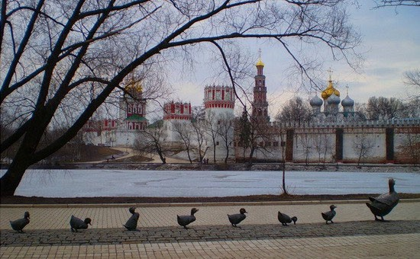

A gift from First Lady Barbara Bush to Raisa Gorbachev in 1991, replica statues of the “Make Way for Ducklings” ducks, inspired by Robert McCloskey’s classic 1941 children’s book, march out in front of Novodevichy Convent in Moscow. The originals can be found in Boston’s Public Garden.

MAKING THE DECISION TO WRITE A THESIS
Writing a senior thesis can be the culmination of a student’s undergraduate career. It requires a serious commitment, and the decision to write a thesis should be made carefully.
There are a number of good reasons to undertake writing a thesis. Work on a thesis offers an opportunity to explore an issue that engages you, to plan and direct your own research, and to draw on the knowledge of methodology and material that you have gained from course work in the concentration. Many seniors have praised the thesis project as the best learning experience of their lives. Be aware, however, that enthusiasm is crucial to the success of a thesis. You should be fascinated by your topic and desire the intellectual adventure of shaping an idea and finding its articulate expression.
As it happens, other reasons may also come into play. Some students feel that they must write a thesis in order to please their parents or their peers. Others see the thesis as a guarantee of admission to graduate school, or of a good job. Still others consider it the clincher for an application or resume. These are not especially good reasons to write a thesis. Since the project represents a considerable investment of your personal time and effort, you should write a thesis for your own sake. Most often the necessary devotion to the thesis grows out of a personally motivated choice. Without this, not only could a poor paper result, but you could very well have a miserable experience in your senior year. If you have any doubts, concerns or questions regarding your decision to write a thesis, please consult with the Director of Undergraduate Studies.
Be honest with yourself about your reasons for wanting to write a thesis and consider carefully the possible ramifications of your choice, both for you and the work. Also bear in mind that a thesis places great demands on your time. The project may be too much if you participate extensively in extra-curricular activities or work outside of school.

CHOOSING A TOPIC AND ADVISOR
The first stages of the thesis project—choosing a topic and an advisor—are perhaps the most difficult. The cardinal rule is to begin early. You should start to think seriously about a topic area and possible advisors no later than the spring semester of your Junior year and discuss this with the Director of Undergraduate Studies. Each April, the Department will hold a Thesis Writing Workshop for junior concentrators, where you will have a chance to talk about your ideas and get feedback from your peers and from Department faculty. Soon after the Workshop, you should contact a potential advisor to discuss your ideas. The faculty member can give you valuable advice at that early stage and suggest reading, even research, for the summer. In addition, there are a number of strategies that you can employ to help you define a topic and find an advisor.

THE TOPIC
A thesis topic should spring from your own energies and interests. The first step toward defining a topic, then, is to determine your primary areas of interest. The role of self- examination in this process is critical.
Look over your past work in the Slavic Studies program and attempt to discover a few general areas of interest. What courses have you taken? What have you written about in course papers? Also, think about why you decided to concentrate in Slavic Studies. As you consider these and other similar questions, you should begin to discern certain patterns or trends in your work. Contemplating these issues will allow you to define your general areas of interest.
Finding a topic within an area of interest is more difficult. A topic is best formulated as a question. But the question cannot be too broad, for a topic must have focus. Nor can it be too narrow, since the goal of a good thesis is to express thoughts of general importance through detailed analysis of a specific case or cases. In short, you want to achieve the proper balance between extensivity and intensity.
Because the purpose of this process is to formulate a focused and thought-provoking question, the best way to uncover topics in your area of interest is to begin posing questions. Start with the issues that stand out in your mind. Also, read some scholarly literature on your subject. If your topic seems too broad, this reading will give you some ideas on approaches you might take. If your question is too narrow, a selection of articles and books can lead you to the general concerns that relate to your interest. And remember, an undergraduate thesis need not be a contribution to knowledge. More important is the sustained examination of a topic that engages you.
If you are unsure about the viability of your topic, you might look at past theses in order to find out what types of projects have been the most successful. The best theses of each academic year are submitted to the Harvard University Archive, which is located on the first floor of Pusey Library. A list of recent honors theses from the Slavic concentration is provided below.

HONORS THESES SINCE 2008

2008
Sara Kate Heukerott, “The Hardest Knot: Structure and the Semblance of Real Life in Tolstoy’s Anna Karenina”
Antonio Ramirez Lupher, “Gogolian Transpositions in Film and Opera: The Overcoat (1926) and The Nose (1930)”

2010
Jordan Bryant, “Russia’s Appian Way: How the Classics Shaped Imperial Identity from Peter I to Alexander I”
Danielle Kijewski, “The Master and Margarita as a Moral Tale: Sin and Redemption in Bulgakov’s Final Novel”
Paul Sawyier, “Russkie Vperyod: Extremism and Neo-Nazism in 21st Century Russia”
Alice E.M. Underwood, “Rights on Parade: The Russian LGBT Community’s Divided March Towards Equality”

2012
Devon Dunn, “Dogs, Divas, and the Men Who Make Them: Decoding Operatic Adaptations of Bulgakov’s
Sobach’ye Serdtse”
Jasper N. Henderson, “Spiritual Imagination: The Literary Icons of Vladimir Nabokov”
Lenore Murphy, “‘I Am a Cuttlefish’: Real Absurdity in the Theater and Life of Daniil Kharms”

2013
Jesse Nee-Vogelman, “Power Adapters: Dimitry Krymov and Kama Ginkas on the Moscow Stage”

2014
Michael Hernani Goncalves, “Art without Iambs: The Free Verse Poetics of Kirill Medvedev”
George Oleg Pocheptsov, “Traces of Oblomov’s Utopia: Applying Methods in Text Mining to Track and Critically Analyze the Thematic, Aesthetic and Linguistic Features of the Dream in the Rest of the Novel”

2016
Claire Chi Atwood, "Transfiguring History: Two Epic Poems About Peter the Great, 1803-1810”

2017
Emma Santelmann, "I'm not the people?": The Fate of the Cross-Cultural Self in Soviet Village Prose and Indigenous Literatures of Siberia and the Far East
Andrew Troska, "Верю: несовместны гений и смерть." Making A Singing Translation of Дети Розенталя.”

2018
Eric Kim, “Dining With Drama: How Pushkin and Gogol create a new tradition.”

2019
Sierra Nota, “Make Way for the Railway: Transit-Oriented Development in the City of Irkutsk”.
Sebastian Reyes, “Benefit Yourself, Your Family, Your Country: Youth Politics in Putin’s Russia, 2000 to Today.”
Alexandra Shpitalnik, “Civil Society in the Shadow of Leviathan: The development and role of socially oriented non-governmental organizations in the Russian Federation.”

2020
Olivia Blanchard, “Kharms’s Incidences: Inviting Participation in a Theater of Prose.”
Nataliya Palinchak, “Through Eastern European Eyes and Under the Western Gaze: The (Un)Feminist Face of the Russo-Ukrainian War.”
Lydia Lavrova, “С Новым Годом - Happy New Year (SNGHNY)” (animation and commentary).

2021
Alyssa Turner, “‘Our Pushkin Was Also a Revolutionist’: Alexander Pushkin in the Imagination of African Diaspora.”

2022
Georgiy Alexander Kent, “Homeland Lost? Crimean Tatar Civil Society Responses to Russia’s Occupation of Crimea.”

2023
Paige S. Lee, “Scorched Wordscapes: A Multidisciplinary Study of the Transformations in Russophone Poetry Before and After the 2022 Invasion of Ukraine.” (Hoopes Prize Winner 2023)

Although you are the only one who can decide what your topic should be, the search should not be conducted in isolation. Once you have defined your broad area of interest, begin talking to your professors and teaching fellows. Their experience can be a great aid in determining the advantages and limits of your various ideas. Turn, as well, to other resources. For example, consult the librarians in the Slavic Division in Widener Library; they may have helpful suggestions about source material.

C.2. THE ADVISOR
An advisor can play a variety of roles in your work on the thesis. It may be more important to find someone who fulfills the roles that are essential to you than to have an advisor who is the leading light in his or her field. Among the roles an advisor can play are:

The Expert: As an expert in your area, an advisor can be a tremendous resource. He or she can provide you with valuable bibliographic references and offer insight into how your topic fits in the larger body of scholarship. Also, your advisor’s intuition may allow you to discern which of your more unusual ideas are potentially productive.

The Taskmaster: Pacing your work is an important aspect of the thesis project. As well as observing official deadlines, you will have to set unofficial ones. An advisor who insists on setting and meeting strict deadlines can provide the necessary motivation for students who have a hard time keeping up.

The Editor: Some students prefer to have an advisor who is unobtrusive when it comes to deadlines and ideas, but who is willing to spend considerable time on style and the mechanics of writing.

The Counselor: In the process of writing a thesis, you will experience many highs and lows. Tremendous excitement alternates with frustration. Disinterest is followed by enthusiasm. And paralyzing anxiety on Monday will make way for vigorous productivity on Thursday. A sensitive advisor can help you through these difficulties.

The Critic: Your advisor can offer constant challenges to your ideas, in an attempt to encourage you to think through every detail of your argument. His or her critical perspective can help you to determine the extent of your progress.

When you begin thinking about your topic, spend some time talking with seniors who are writing theses. They will be able to give you an idea about what combination of roles their advisors fulfill. This information will be invaluable as you consider possible advisors. Once you have determined your chosen area of interest, consultations with faculty and teaching fellows will enable you to refine your ideas and to initiate the search for an advisor. Your meetings with them will give you an opportunity to judge how well they might be able to respond to your plans and needs. If a faculty member appears interested in your project and seems to possess the combination of skills you seek in an advisor, simply ask if he or she is available.

Although it is not required, you are strongly encouraged to secure an advisor by the end of your Junior year. This will permit you to set up a reading list for the summer and will make for a good start in the Fall.

GRANTS FOR THESIS RESEARCH
A number of university-based organizations sponsor grants for undergraduates that are designed to support thesis research. Among the most notable in the Slavic field is the Davis Center for Russian and Eurasian Studies.
Private organizations also support grants that can be used for thesis research, such as The Ford Program for Undergraduate Research. For details concerning these and other grants you may be qualified for, consult the current Harvard College Guide to Grants and contact the Fellowships Office at the Office of Career Services.

MANAGING THE PROJECT
The importance of organization in your work on the thesis cannot be overemphasized. Once you have an advisor, sit down with them and map out a timetable. Good long-range planning is vital in grappling with such a large project, especially since you are unlikely to have had any experience with a similar endeavor. Your own plans should include developing a good relationship with your advisor. As in any working relationship, communication is the key to productivity. Try to schedule regular meetings with your advisor and do all you can to make them substantive. The frequency of your meetings will doubtless vary over the course of the semester. Most students meet more often with their advisors once they have begun writing.

RESEARCH: THE INITIAL STAGES
The first stages of research should begin during the summer after your Junior year. This is a time to undertake both background and theoretical reading. Your work will lead you to take the first steps in moving from topic to argument, perhaps the most important aspect of the whole thesis project. A topic is a well-defined area of interest; an argument consists of the point you want to make about your topic and the reasons that support it.
When you return in the fall, it will be time to set about more focused research. Refining your topic and determining your argument is part persistence and part trial and error. By the end of September you should be in a position to write your prospectus. A prospectus is a statement of approximately three pages about your refined topic and your proposed argument. In addition, the prospectus should include a summary of what you hope to accomplish through further research, and if possible should sketch out a plan of the chapters of the thesis. Students who plan to take Slavic 99b must submit a prospectus to their advisors on or before September 30. You should schedule a separate meeting with your advisor to discuss the prospectus in the week or so after you turn it in.

RESEARCH AND WRITING
Once you have completed your prospectus, you will begin an extended period of research and writing. A project as large as a thesis should be done incrementally. Plan to work on your chapters separately—first researching, then writing. At this stage observing a strict timetable is essential. Set aside time for intense research on a given chapter. When that time is up, start writing immediately. Of course, research will not stop completely until you begin editing your thesis, but succumbing to the temptation to continue research will prevent you from pacing your writing properly. You should expect to write a number of drafts for each part of the thesis project; the more you work over each chapter, the better your thesis will be. And remember, as long as you start writing early, you will have time to reopen any line of research later on.
A requirement of approximately 15-20 pages to be submitted to your advisor by the last day of classes (December 5) has been established by the Department in order to encourage you to begin writing early.
In the process of writing, you are bound to meet with a variety of difficulties. Your thesis advisor can be instrumental in working through certain problems, but do not hesitate to make use of informal advisors. Talk over your difficulties with your friends and also with your Teaching Fellows. Perhaps even show a draft to someone who knows nothing about your topic, as a test of how well your ideas are coming across. The Writing Center, located in the basement of Barker Center, can be a valuable source of advice on the mechanics of writing. The Center offers special help on senior theses in addition to its regular services: conferences by appointment and drop-in hours, not to mention a wide array of hand-outs and reference books on writing.
A completed draft of the thesis must be submitted to your advisor by the fourth Friday in February (February 23). This deadline has been established by the Department in order to give you sufficient time for substantive revisions, editing and production.

PRODUCTION (FORMATTING, PRINTING, BINDING)
Give yourself plenty of time to produce clean copies of your thesis. Refer to the section on thesis regulations below for the Department format requirements.

THESIS RULES AND REQUIREMENTS
All theses submitted to the Slavic Department must conform to the following requirements:
LENGTH: The recommended length for theses in the Department is 70 pages.
STYLE: The style of your thesis must conform to the standards of either of the following reference works: The MLA Style Manual or Kate L. Turabian, Manual for Writers of Term Papers, Theses and Dissertations.
CITATIONS: Russian passages included in your thesis should be printed in Cyrillic characters; you should provide a translation of all Russian passages in a footnote following each quotation. Be sure to give proper credit for all translations, whether they are your own or are taken from a published source.

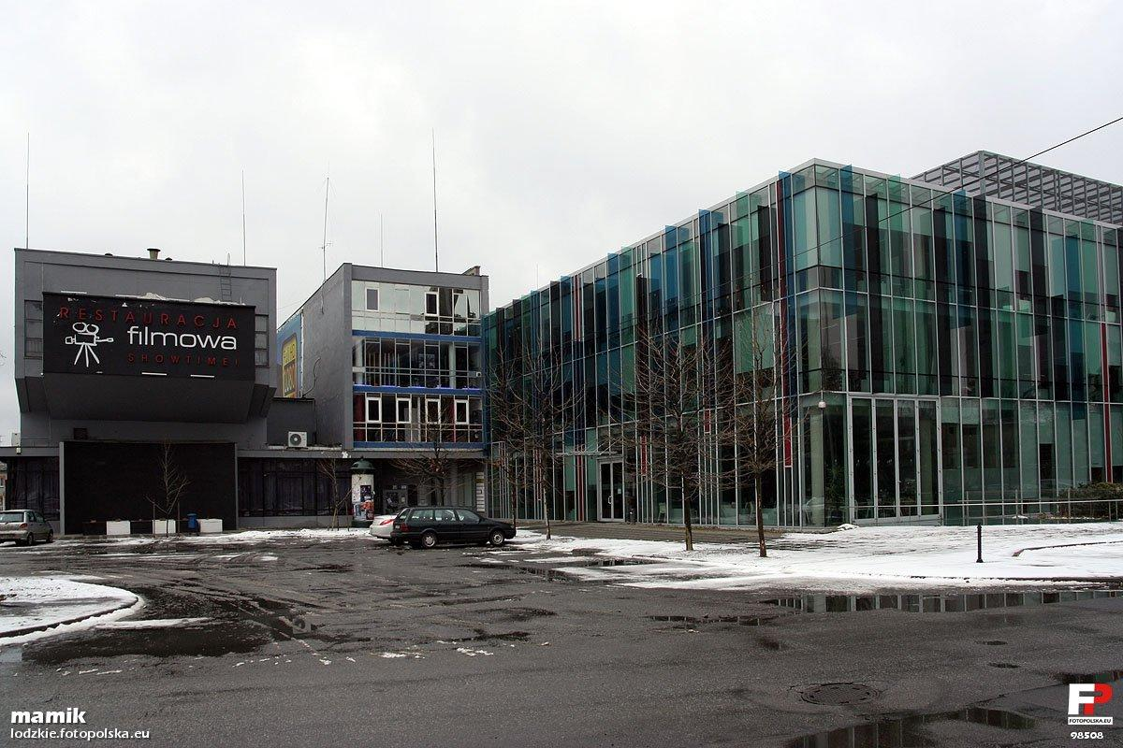
Wytwornia Filmow Fabularnych (Feature Film Studio) in Lodz, Poland. This studio was the production site for several well-known masterpieces of postwar Polish cinema, including Andrzej Wajda’s 1957 drama of the Warsaw Uprising Kanal.
TITLE PAGE: A title page is required and must comply with the format below:

TITLE (in caps)

by (Name)

An Honors Thesis

Presented in Partial Fulfillment of the Requirements for the Degree of Bachelor of Arts Department of Slavic Languages and Literatures

Harvard College Cambridge, Massachusetts

(Month and Year of Submission)

PAGE FORMAT: All pages of the thesis text must conform to the following standards:
  - margins: left, 1.5 inches; all others, 1 inch;
  - pages must be double-spaced;
  - author’s name and page numbers (i.e., Last Name pg.#) must be included in the top right-hand corner of each page, two lines above the top margin;
  - notes may be placed at the bottom of the page or at the end of the text. PRINTING: All printing must be of the highest quality.
SUBMISSION: Please submit your thesis as a pdf file to the Director of Undergraduate Studies and Department Administrator. Paper copies of your thesis should be submitted in black, hardcover, spring binders. Free binders may be available in the Slavic Department.

COMPUTERS AND PRINTERS
Computers and printers are the crux of some senior thesis horror stories. Head this off! Print your final draft about three or four days before the thesis is due. Again, this may sound early, but if you suddenly discover that the pagination is confused or that your notes are appearing at the top of the page instead of the bottom, you will be thankful to have started well before the deadline.

PROOFREADING
Be sure to allow enough time to proofread your final draft. A poorly proofread paper creates an impression of sloppiness and carelessness that can easily be attributed to your writing and thinking and can lower your grade.

COPYING
The last stage of production is photocopying. Here, as before, plan to do your copying early. Try to get the thesis into the copy shop at least two days before it is due.
Remember, half of the senior class may be queued up in front of you, so don’t wait until the last minute.

TURNING IN YOUR THESIS
Your thesis is due on the last Wednesday before Spring Recess. This year theses are due on March 6. Please submit two copies of your thesis to the Slavic Department, one to the Department Administrator, and one to your advisor (which is a very nice way to thank them for their work with you). These copies may be digital (in PDF format) or printouts, and the Department has binders in the Slavic Department office which you may use if you wish to submit bound copies.

GRADING
The submitted thesis is evaluated by two faculty members, neither of whom is the thesis advisor, and each assigns a grade. The readers write detailed comments which are given to you and shared with the rest of the Department faculty. At the discretion of the Director of Undergraduate Studies, a third reading may be required. The Department will use the University’s 4-point scale to determine the thesis grade. Evaluations of 3.00 points and above are assigned honors status as shown in the chart below. Theses whose grades average Magna or above will be placed in the University Archives.
Please note that the grading scales used here apply only to courses and theses, not degrees. Historically, the cutoffs for magna and cum degrees have been significantly above the magna minus and cum minus levels (i.e., magna minus means “not quite a magna”). Furthermore, Harvard College requires a minimum overall grade point in your field-of-concentration courses of 2.83. In accordance with University custom, students will not be recommended for Highest Honors unless their thesis receives at least one reading of summa cum laude (summa minus is acceptable). The above Honors calculations are the Department’s ratings, not the College’s. Details of the College’s Honors calculations are provided in the FAS Handbook for Students.

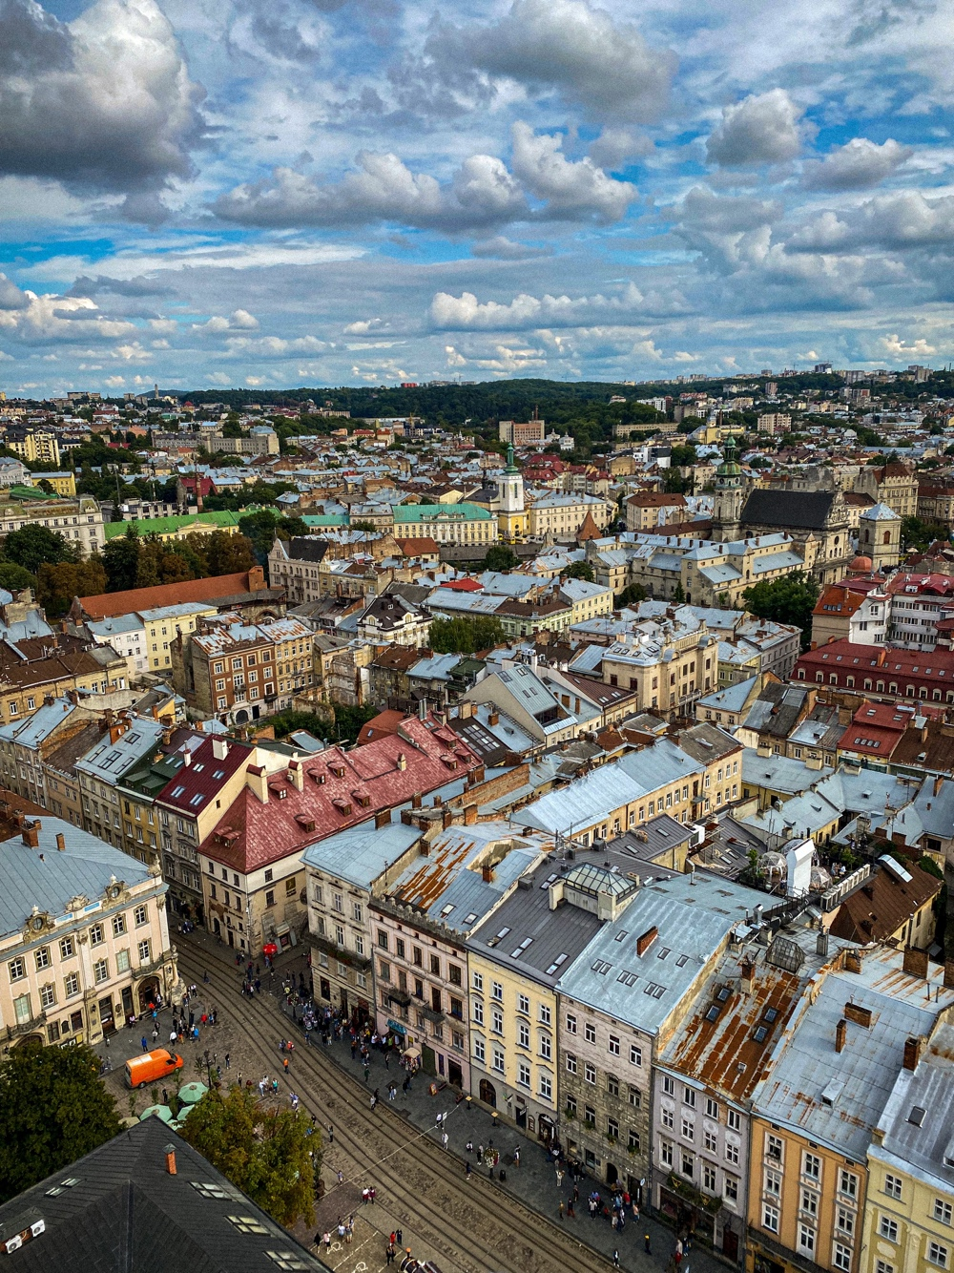
A panorama of the Old Town in Lviv, Ukraine, a UNESCO World Heritage Site. A longstanding center of Ukrainian cultural foment, Lviv’s complicated history encompasses sites of Ukrainian, Polish, Jewish, and shared memory. Today, in the aftermath of Russia’s brutal invasion of Ukraine, Lviv pulses with activity as volunteers distribute food to refugees, poets perform to packed underground (literally) venues of Ukrainian servicemen, and ordinary people try to go about their lives under wartime conditions.

GRADING
Co. Grades | Numerical Weights |  | Thesis Grades (Department’s ratings)
A | 4.00 | summa cum laude |  | Honors
 | 3.83 | summa cum laude minus |  | ⭣
A- | 3.67 | magna cum laude plus |  | ⭣
 | 3.50 | magna cum laude |  | ⭣
B+ | 3.33 | magna cum laude minus |  | ⭣
B | 3.00 | cum laude plus |  | ⭣
 | 2.83 | cum laude |  | Non-Honors
B- | 2.67 | cum laude minus |  | ⭣
 |  |  |  | ⭣
C+ | 2.33 |  |  | ⭣
C | 2.00 |  |  | ⭣
C- | 1.67 |  |  | ⭣
 |  |  |  | ⭣
D+ | 1.33 |  |  | ⭣
D | 1.00 |  |  | ⭣
D- | .67 |  |  | ⭣
 |  |  |  | ⭣
E | 0.00 |  |  | ⭣

PRIZES
For more information on awards you may qualify for, for instance the Thomas T. Hoopes Prize and the George B. Sohier Prize, consult the website https://prizes.fas.harvard.edu/prize-descriptions.

HONORS

HONORS REQUIREMENTS
The requirements for Departmental honors are: 13 semester courses, as described on page 9, including the thesis, as described on pages 9-29.
Bear in mind that you need not fulfill the departmental honors requirements in order to graduate with honors from Harvard. Those who do not wish to undertake an honors program may qualify to receive a degree of Cum Laude in General Studies.

DETERMINATION OF HONORS
The first step in the determination of honors is the calculation of a departmental ranking. This ranking is based on the student’s grades in course work and on the thesis, with each factor weighted equally.
Only grades from concentration courses will be considered in the determination of a student’s departmental ranking. Please note that an overall summa degree recommendation is dependent on a student achieving a summa reading on his or her thesis. The numerical equivalents used in the calculation of this formula are assigned according to the 4-point scale below established by Harvard College. There are no longer fixed numerical ranges for the various Honors levels. However, the Slavic Department will use the distribution below as a guideline in its degree recommendations.

Highest Honors = 3.83-4; High Honors = 3.67-3.83; Honors = 3.00-3.67

A = 4.0  A/A- = 3.83 | B+ = 3.33  B = 3.0 | C+ = 2.33  C = 2.0 | D+ = 1.33  D = 1.0
A- = 3.67 | B/B- = 2.83 | C- = 1.67 | D- = .67
A-/B+ = 3.5 | B- = 2.67 |  | F = 0.0

The ranking established in the above formula is not in itself a determination of honors. Rather, it is a guideline according to which the Department faculty may reach a decision. Each student’s record is considered according to its own merits and certain unquantifiable factors inevitably play a role in determining the departmental recommendation to the Faculty of Arts and Sciences. Students recommended for High Honors or Highest Honors will normally have taken a range of demanding courses, including advanced language work (beyond the third year) and 100-level courses in the Slavic Department. In the final stage of honors determination, the Faculty of Arts and Sciences will either accept the Department’s recommendation or amend it according to established rules.

CAMPUS RESOURCES

LIBRARY RESOURCES
Harvard University holds one of the largest Slavic collections outside the Former Soviet Union and East Central Europe. The main collection of volumes in the areas of the humanities and social sciences is housed in Widener Library. Manuscripts, rare books, and materials in the areas of fine arts, music, anthropology, ethnology, law, and science are housed in other specialized libraries. The Harvard Libraries hold a treasure trove of both print and electronic materials that will facilitate, inform, and inspire your research. Concentrators are invited to contact the Librarian for the Davis Center, to help you discover more about the Slavic collections and to make contact with the other librarians who are expert in a wide range of Slavic Languages. They will be happy to give you an orientation to using the libraries and to teach you to be an expert navigator and researcher in the Harvard library system.
Here are some of the specialized Harvard libraries with holdings of import and interest to the student of Slavic studies:
Fung Library: located on the basement level of 1737 Cambridge Street, this is the Davis Center for Russian and Eurasian Studies’ library and is especially useful for its collection of current Russian periodicals.
Houghton Library: located in Harvard Yard, east of Widener, Houghton is an invaluable resource for rare books and manuscripts.
Fine Arts Library: located on the first floor of Littauer Center, this library includes a collection of slides and photographs, in addition to numerous books on the Slavic visual arts.
Aside from its standard collection, the Harvard library system contains a variety of special collections and archives. Among the most notable are:
The Kilgour Collection of Russian Literature: housed in Houghton Library, this collection of first editions of Russian literature is one of the best assembled outside Russia. A guide to the collection is available in the Widener Reading Room [RR 3402.15].
The Harvard Trotsky Archive: arrangements for the sale and shipment of this archive to Harvard were made by Trotsky himself. The archive contains all papers that were in Trotsky’s possession at the time of his death; they date from 1917 to 1940. A guide to this archive is available in Houghton Library.
The Milman Parry Collection: a special collection of oral literature, its forte is South Slavic folk literature.
The Dana Collection: this is a collection of material relating to theatrical life in the early decades of this century. Its holdings include programs, photographs, manuscripts of plays and clippings.

THE DAVIS CENTER FOR RUSSIAN AND EURASIAN STUDIES
1730 Cambridge Street, CGIS South, Third Floor
The Davis Center for Russian and Eurasian Studies plays a vital role in the pursuit of Slavic Studies both at the University and in the Boston area. Scholars and professionals from all over the world come to the Davis Center for the purposes of conducting research at Harvard and engaging in the active intellectual life at the Center. The Center sponsors talks and seminars on a wide range of topics, and all seminars welcome undergraduates, who are also encouraged to attend the Center’s special lectures. Each year the Center awards travel grants of up to $5000 for undergraduate summer research towards the senior research thesis in topics pertaining to East-Central Europe and the former Soviet Union. Applications are due in the spring.

Please refer to https://daviscenter.fas.harvard.edu/academic-programs/undergraduate-studies/undergraduate-grants for more details about these grants. For information on current events at the Center, consult their calendar listings at http://daviscenter.fas.harvard.edu. Participation in the Center’s various activities can serve as a stimulating supplement to your academic program.

THE HARVARD UKRAINIAN RESEARCH INSTITUTE (HURI)
34 Kirkland Street
The Institute was founded in 1973 as part of an effort to promote Ukrainian Studies at Harvard. The primary objectives of HURI are to support basic research projects and to publish scholarly works, as well as annotated bibliographies and teaching materials in Ukrainian history, literature and language. Over 25 conferences and symposia on topics related to Ukrainian Studies have been sponsored by the Institute. HURI is also co- organizer with the Harvard Summer School of the Ukrainian Summer Institute, a seven- week intensive academic and extra-curricular program. For more information about the Institute or Ukrainian Studies at Harvard, call (617) 495-7835 or visit their web site at http://www.huri.harvard.edu/.

OTHER RESOURCES
There are many other campus resources that may be of interest to concentrators in Slavic Studies. In particular, the Harvard University Film Archive periodically sponsors festivals of Slavic cinema as well as screenings of individual films, and the Humanities Center, located in Barker 136, sponsors a wide range of lectures and readings in literary and cultural studies.
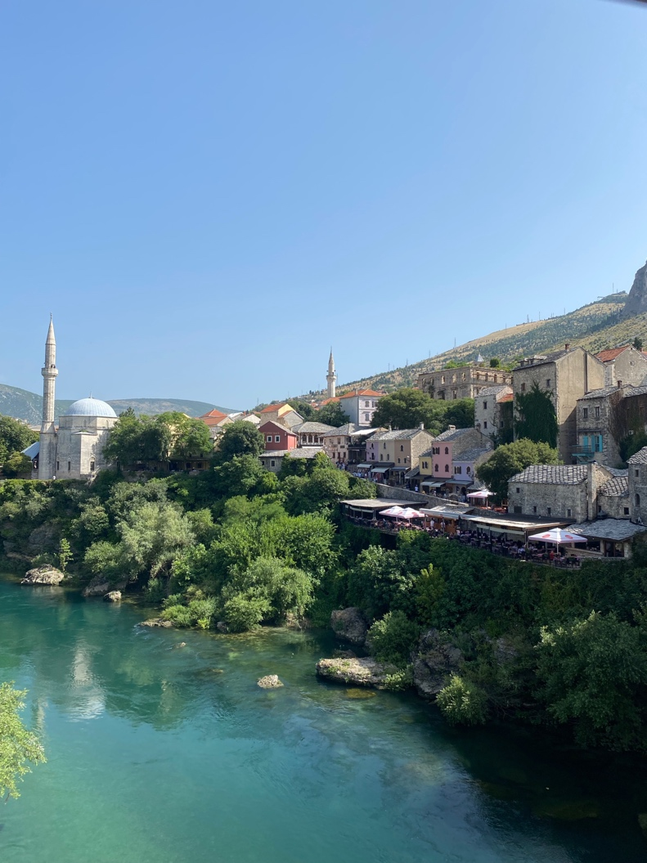
A view of Sarajevo. The cityscape of Sarajevo, long a crossroads and meeting point of different cultures, reflects the city’s history: in this shot, one can see Habsburg, Islamic, and vernacular Balkan architectural traces.
Photo taken by Sydney Stotter

OFF-CAMPUS STUDY

STUDY ABROAD
Usually, the Department encourages all concentrators to consider spending part of their undergraduate tenure abroad. Participation in a summer or semester program, however, is neither required nor expected by the Department. The faculty promote study abroad because it has proven to be an extraordinarily enriching experience for so many students. The benefits to be reaped from a stay in Prague, Warsaw, Tbilisi or another East or Central European city are not limited to increased proficiency in the language; direct contact with the people and culture can be one of the most invigorating personal and intellectual experiences of a lifetime. We recognize that study abroad can be difficult under current conditions. The Slavic Department faculty and staff are constantly monitoring issues of safety for travel abroad and we will always revise our recommendations in accordance with current university and other federal guidelines.

GENERAL INFORMATION
The number and variety of educational programs in Eastern Europe and the former Soviet Union have expanded dramatically in recent years. In order to receive credit for study abroad, students must participate in an approved program. Basic information about the most established programs is provided below. Please contact the program directly for the most up-to-date information.
Financial aid is available for most if not all of these programs, and any financial aid you receive from Harvard may be applied toward a semester or academic year program.
Consult the Office of International Education for details: http://oie.fas.harvard.edu/.
In addition, selected Harvard grants can also be used to defray the costs of a study-abroad program. For example, women students may apply for either the Isabel L. Briggs Travelling Fellowship or one of the Josephine Murray Travelling Fellowships. For more information on these and other available grants consult the current Harvard College guide to grants at https://college.harvard.edu/resources/guide-finding-funding.
Each year in the fall the Department conducts an informal informational meeting for students interested in Summer Language and Study Abroad programs. Questions concerning all aspects of off-campus study are entertained at this meeting. In addition, strategies for application to these programs are outlined by the Director of Undergraduate Studies, the Director of the Language Program, and former participants and leaders.
Students who spend a semester studying abroad should consult with the DUS to determine which courses abroad will count for which concentration credits. In general, most students who receive credit for two courses in Russia will be exempted from one semester of junior tutorial and one of their departmental electives, at the DUS’s discretion. Except in unusual circumstances, credit for the survey course will not be given for study abroad.
In general, full semester concentration credit (i.e., 4 courses) is granted to students who earn adequate grades during a semester of study in an approved program. Those who successfully complete a summer will receive half-semester concentration credit (i.e. 2 courses).

For other questions regarding credit, please see the Director of Undergraduate Studies, Stephanie Sandler (ssandler@fas.harvard,edu). For questions regarding Study Abroad Programs, please see Steven Clancy, the Director of the Language Program and the Study Abroad Advisor for the Slavic Department (sclancy@fas.harvard.edu).

N.B.. In light of Russia’s invasion of Ukraine in February 2022, the situation with Study Abroad in the region is very complicated. The programs listed below were previously approved by OIE, but many have since changed location and format. The Department is in close communication with OIE about programs in the region and can provide guidance on what the best program is for you based on your individual goals and needs. It is imperative that credit approval be sought at OIE and with the Director of Undergraduate Studies before participation in any program.

NON-HARVARD PROGRAMS IN RUSSIA AND EASTERN EUROPE
You will find below the most up-to-date information available on the major study programs for which Harvard gives credit. Contact the program directly for up-to-date information about dates, fees, and deadlines. Information on other study and touring programs is also available in the Office of International Education.
Remember! To receive Harvard credit, you must petition the Office of International Education before you leave. Participation in some of these programs is subject to OIE approval of their new site and format.

ACTR: (American Council of Teachers of Russian)
ACTR-Russian Outbound Programs Office 1776 Massachusetts Avenue, NW
Suite 700
Washington, DC 20036
Phone: (202) 833-7522
Fax: (202) 833-7523
Email: outbound@americancouncils.org URL: www.actr.org
RLASP (Russian Language and Area Studies) program offered for the summer, fall, spring and academic year in Kazakhstan, Armenia, and Georgia. Students receive approximately 20 hours a week of instruction in Russian language, with additional coursework on the history, culture, and language of the host country. The program includes homestays, weekly excursions, and a wide range of volunteer and extracurricular opportunities. Participants receive academic credit through Bryn Mawr College.

American Councils also offers Ukrainian language study in Moldova through their Eurasian Regional Language Program (ERLP), as well as BCS through their Balkan Language Initiative (BLI).

CIEE: (Council on International Educational Exchange)
633 Third Ave., 20th Floor New York, NY 10017 Phone: (800) 407-8839
Fax: (212) 822-2779
Email: RussiaRegistrar@ciee.org URL: www.ciee.org
Russian Language + European Studies program offered in the fall and spring in Tallinn, Estonia.
Students take courses in Russian language and culture, Baltic languages and culture, public diplomacy, and other subjects through CIEE’s partner universities in Tallinn. Students also have the opportunity to participate in an internship during their time in Estonia.
Students apply to CIEE through American sponsoring institutions whose internal deadlines may be earlier than those for CIEE.

Bard Abroad in Bishkek
30 Campus Road, PO Box 5000
Annandale-on-Hudson, NY 12504
Phone: (845) 758-7835
Email: studyabroad@bard.edu
URL: www.bard.edu/studyabroad

Students take intensive Russian-language courses at American University of Central Asia in Bishkek, Kyrgyzstan, with the opportunity to take electives in Kyrgyz language, Central Asian literature, and other topics. Students participate in homestays with Russian-speaking families, as well as cultural excursions to sites throughout Kyrgyzstan.

HARVARD SUMMER SCHOOL PROGRAM IN THE CZECH REPUBLIC
51 Brattle Street
Cambridge, MA 02138
Phone: (617) 495-4024
Fax: (617) 495-3662
URL: https://summer.harvard.edu/study-abroad/prague-czech-republic/

Harvard Summer Program in Prague, Czech Republic Faculty: Veronika Tuckerova
The Harvard Summer Program in Prague is an eight-week intensive program in Czech language and culture. Based in a country that is rich in tradition and yet rapidly changing since the fall of communism in 1989, the program appeals to students who would like to learn more about central European culture, broaden their perspectives on global politics and history, learn a Slavic language, and spend a summer getting to know one of Europe’s most beautiful cities.
In addition to intensive language study, students examine the complex cultural, religious, and political forces that have shaped Czech society. Language and cultural study will be supplemented with walking tours of Prague and visits to magnificently preserved cathedrals, castles, churches, synagogues, museums, and monasteries.
We explore the gardens of the Vyšehrad Castle, the Royal Palace, and the St. Vitus Cathedral of the remarkable castle complex Hradcany, and visit art collections housed in the thirteenth-century St. Agnes cloister, St. George’s Basilica, the Valdštejn, and the Schwarzenberg Palaces.

Harvard Summer Program in Tbilisi, Georgia Faculty: Steven Clancy
The Harvard Summer Program in Tbilisi offers you the hands-on experience of living and studying in the capital of the Republic of Georgia along with a full course in intermediate Russian language meeting daily. Russian and Georgian culture, history, literature, film, and urban studies will be covered in topic modules meeting two to three times each week. These modules will provide a larger context for Georgia and Russia and will make use of Tbilisi as a laboratory, including meetings with writers, politicians, and NGOs. All modules and topics will be accompanied by excursions and trips within Tbilisi and throughout Georgia.
A pre-departure introduction to Georgian language will be available for participants and additional Georgian language study may be arranged as part of the program in Tbilisi for those desiring to study Georgian.

NB: Other programs may be approved for credit on an individual basis. If you have selected a program that is not listed here, see the Director of Undergraduate Studies to inquire about credit. Also available are excellent noncredit programs that offer work (camp counseling, internships).

SUMMER STUDY IN THE U.S.
Some concentrators opt to supplement their language instruction at Harvard with training during the summer in the United States. Aside from standard summer school courses, some colleges and universities offer immersion programs. Students in these programs are required not only to take intensive courses, but also to speak Russian outside of class: at meals, in the dorms, on campus. Though no additional credit is offered to participants in immersion programs, many students find that the rewards are worth the extra effort and commitment.
Credit for summer school in the U.S. is offered according to the same guidelines as those for study abroad. The student must be enrolled in an approved program and, upon successful completion, will receive half-semester concentration credit (i.e., 1 full course). Please speak with the Director of the Language Program or the Director of Undergraduate Studies if you wish to study in the U.S. during the summer.

N.B. Again, any student who wishes to receive credit for work completed during the summer must have the approval of OIE and the Director of Undergraduate Studies before participation in any program.
Below you will find the addresses of some approved immersion programs and information on the Harvard Summer School program.

  - U.S. IMMERSION PROGRAMS

Bryn Mawr Russian Language Institute Middlebury Russian School
Russian Center Middlebury College
815 New Gulph Road Middlebury, VT 05753 Bryn Mawr, PA 19010

Indiana U. Slavic Workshop Dept. of Slavic Languages Ballantine Hall 502
Bloomington, IN 47405

HARVARD SUMMER COURSES IN CAMBRIDGE
For information see the Harvard Summer School’s website at http://www.summer.harvard.edu or call 617 495-4024. Course information for the upcoming summer is added to the Summer School website typically in mid-January.
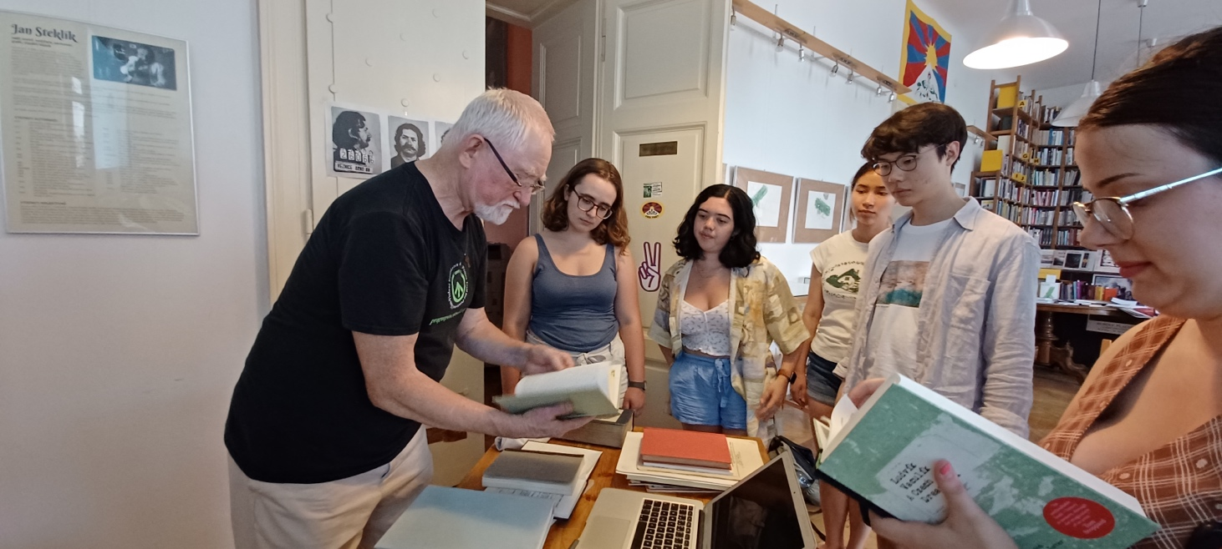
Students on the Harvard Summer in Prague program examine examples of samizdat literature at Libri Prohibiti in Prague. Underground samizdat (self-published) works provided a valuable outlet for cultural expression and political activism under repressive regimes in the former Warsaw Pact. Samizdat publishing was sophisticated and multifarious in socialist Czechoslovakia, with publications running the gamut from the works of Czech dissident author Vaclav Havel to a Czech translation of Tolkien’s The Lord of the Rings. Libri Prohibiti was founded in 1990 to archive, collect, and research samizdat in the former Czechoslovakia and beyond.

EXTRA-CURRICULAR OPPORTUNITIES
Besides events sponsored by the organizations listed in Section VII (Campus Resources) of this handbook, there are many other activities both on and off campus that can expand your skills, enrich your knowledge and simply be a source of fun. For example, Slavic language tables are scheduled regularly at some Harvard houses throughout the school year. They offer an opportunity to enjoy the company of fellow students of Slavic culture and to exercise your target language. Also, there is a large Russian-speaking population in the Boston area. In the past, for example, students have volunteered as interpreters at hospitals and agencies that serve the Russian community.
In the past, undergraduates in the Department have also sponsored their own activities and events, sometimes in conjunction with the graduate students. In recent years, for example, we have had Slavic poetry slams and mini film festivals of Russian and East European film. Often the Davis Center for Russian and Eurasian Studies has in its budget a few hundred dollars available for undergraduate activities. This money may be used, in whole or in part, for any Slavic-oriented activity organized by undergraduates. If you are interested in organizing film showings, inviting a lecturer, or organizing other events, please consult the Director of Undergraduate Studies about the possibility of using these funds. In addition, the Slavic Department in the recent past has organized a couple of annual events, such as a play, poetry reading, and/or musical performance, in which our concentrators and other Harvard students studying Slavic languages and cultures are the main participants. Late in the spring term, the Davis Center sponsors the Undergraduate Colloquium on Russian and Eurasian Studies, when Harvard, Wellesley, and Wheaton students come together to present their major works, capstone projects, and senior theses.

DEPARTMENT OF SLAVIC LANGUAGES AND LITERATURES STAFF

Penelope Skalnik, Department Administrator (Barker 374, (617) 495-0912, pskalnik@fas.harvard.edu)
Augustus Gilchrist, Department Coordinator (Barker 380, (617) 495-4065), augustus_gilchrist@fas.harvard.edu)
The Slavic Department staff is available to help you with a variety of concerns. The Department offices are located in Barker Center 374 and 380 and are generally open Monday through Friday, 9:00 a.m.-5:00 p.m. Please feel free to contact Penny and Augustus for assistance.

DEPARTMENT OF SLAVIC LANGUAGES AND LITERATURES FACULTY

Jonathan Bolton, Professor
Interests: Czech literature and history in a Central European context; cultures of dissent during the Cold War; literary theory and theory of literary history; memoirs and first- person historical writing; translation studies.

Julie Buckler, Samuel Hazzard Cross Professor of Slavic Languages and Literatures
Interests: Russian literature (18th and 19th centuries and pre-revolutionary fiction), West European and American literature, cultural studies and semiotics, gender studies, performing arts (opera, theater, music), St. Petersburg, memoir and autobiography, literary canon and popular culture.

Steven Clancy, Senior Lecturer and Director of the Language Program.
Interests: cognitive linguistics; linguistic typology, computational linguistics, semantic maps, language pedagogy.

Veronika Egorova, Senior Preceptor.
Interests: Russian language teaching at all levels, teaching heritage speakers, teacher training and the use of technology in STARTALK programs.

Michael S. Flier, Oleksandr Potebnja Professor of Ukrainian Philology.
Interests: Slavic linguistics; Ukrainian, Russian and Belarusian historical dialectology; semiotics of medieval East Slavic culture.

Daria Khitrova, John L. Loeb Associate Professor, Director of Graduate Studies
Interests: 19th and 20th century Russian poetry, prose, film, theater, ballet, and the movement of cultural tropes from one tradition to another.

Aleksandra Kremer, John L. Loeb Associate Professor.
Interests: Polish literature and culture, literature and the visual arts, poetics and literary theory, poetry performance, Polish-Jewish relations, migration, and translation

Stephanie Sandler, Ernest E. Monrad Professor of Slavic Languages and Literatures, Director of Undergraduate Studies
Interests: Modern Russian poetry; film; psychoanalytic and gender studies; Pushkin and myths of Pushkin; post-Soviet culture; autobiography and memoirs; comparisons with American literature; translation

Nariman Skakov, Associate Professor.
Interests: Russian literature, especially modernism and postmodernism, film studies, literary and visual studies, literature and science, cultural theories.

Nataliya Shpylova-Saeed, Preceptor.
Interests: Memory studies, cultural memory in Ukraine, epistolary forms, Ukrainian literature, Mykola Hohol, Taras Shevchenko, Lesia Ukrainka, Ivan Franko, Volodymyr Vynnychenko.

Veronika Tuckerova, Senior Preceptor.
Interests: Czech language teaching at all levels.

Justin Weir, Curt Hugo Reisinger Professor of Slavic Languages and Literatures and Professor of Comparative Literatures and Department Chair
Interests: 19th- and 20th-century Russian prose, intellectual history, film and visual art, literary theory.

APPENDIX I

TRANSLITERATION OF RUSSIAN
The aim of transliteration is to give a letter-for-letter equivalent of Russian spelling by means of the Roman alphabet. Most recent senior theses have used the Library of Congress system, which is also used in the Harvard libraries. It differs in a few important details from the Linguistic system, which is used primarily for language and linguistic work. For your convenience, both systems have been included in the table below.
Please write to the Department Coordinator (Augustus Gilchrist, augustus_gilchrist@fas.harvard.edu) for transliteration tables for Ukrainian, Polish, BCS, or Czech.
Cyrillic Alphabet: Systems of Transliteration
Russian |  | Cyrillic | Library of Congress | Linguistic
А а |  | А а | A | a
Б б |  | Б б | B | b
В в |  | В в | V | v
Г г |  | Г г | G | g
Д д |  | Д g | D | d
Е е |  | Е е | E | e
Ё ё |  | Ё ё | Ё | ё
Ж ж |  | Ж ж | Zh | ž
З з |  | З з | Z | z
И и |  | И и | I | i
I i |  | I i | I | i
Й й |  | Й й | Í | j
К к |  | К к | K | k
Л л |  | Л л | L | l
М м |  | М м | M | m
Н н |  | Н н | N | n
О о |  | О о | O | o
П п |  | П п | P | p
Р р |  | Р р | R | r
С с | С с |  | S | s
Т т | Т т |  | T | t
У у | У у |  | U | u
Ф ф | Ф ф |  | F | f
Х х | Х х |  | Kh | x / ch
Ц ц | Ц ц |  | Ts | c
Ч ч | Ч ч |  | Ch | č
Ш ш | Ш ш |  | Sh | š
Щ щ | Щ щ |  | shch | šč
Ъ ъ | Ъ ъ |  | “ | “
Ы ы | Ы ы |  | Y | y
Ь ь | Ь ь |  | ‘ | ‘
Э э | Э э |  | È | è / ė
Ю ю | Ю ю |  | Iu | ju
Я я | Я я |  | Ia | ja
Θ θ | Θ θ |  | F | f
V v | V v |  | I | i

There is a handout available in the Slavic Department which provides further details and a multitude of examples. The most important thing is to be consistent in your transliteration; mixing systems is acceptable only when citing other works, or in special cases that you announce at the beginning of a paper. For example, scholars often choose to use common spellings of familiar names (Chekhov, not Čexov; Tchaikovsky, not Čajkovskij; Tolstoy, not Tolstoj etc.) and make a note of it in the preface of their works.

APPENDIX II

Secondary Fields
The Department of Slavic Languages and Literatures provides a broad array of courses in the languages, literatures, and cultures of Russia, Ukraine, Poland, Bosnia-Croatia-Serbia, and the Czech Republic. For a secondary field, we offer two options: Central European Studies or Russian Studies. Both require students to take 5 related courses and offer ample scope for interdisciplinary and comparative work. We offer students the chance to work closely with Slavic faculty in order to develop a program of study suited to their own interests, rather than just an accumulation of five loosely related courses.
Central European Studies (5 courses)
- At least three courses in Central European literature and culture (broadly speaking, Bosnian- Croatian-Serbian, Czech, Polish, or Ukrainian) in the Slavic Department
- Up to two thematically relevant courses offered by departments such as History, German, Government, Literature, Jewish Studies/NELC, Social Studies, and VES may be counted with the approval of the Slavic Director of Undergraduate Studies.
- One language course in Bosnian-Croatian-Serbian, Czech, Polish, or Ukrainian may be counted.

Russian Studies (5 courses)
- At least three courses in Russian literature and culture from the Slavic Department, including at least one survey course in Russian literature.
- Up to two thematically relevant courses offered by departments such as History, German, Government, Literature, Jewish Studies/NELC, Social Studies, and VES may be counted with the approval of the Slavic Director of Undergraduate Studies.
- One language course in Russian may be counted.

Other Information
All courses (except for First-Year Seminars) must be letter graded. Slavic related Gen Ed courses and First-Year Seminars are permitted. Any number of relevant Gen Ed courses and one First-Year Seminar may be counted. Students may use Harvard-approved study abroad credit to count for up to two courses toward the secondary field. Students are required to take a minimum of two 100-level courses.

Advising Resources and Expectations
All students interested in pursuing a secondary field from the Slavic Department should contact the Director of Undergraduate Studies (DUS), Professor Stephanie Sandler(ssandler@fas.harvard.edu) as soon as possible to discuss their program of study. The DUS will be responsible for advising students, who will also be welcome to consult with other Slavic faculty, although the expectation will be that students will monitor their own progress towards fulfillment of the requirements.

